**FORM 4 PREDICTOR 2,2025**

**MARKING SCHEME**

**SECTION A**

*Answer* ***all*** *the questions in this section.*

1. (a) What is the relationship between Geography and Mathematics? (2 marks)

**Geographical concepts are applied in calculating direction / bearing in mathematics.**

**Mathematical formulae and principles are used in Geography to calculate area, distance, bearing, percentage, density, etc.**

(b) Identify **three** branches of Geography. (3 marks)

• **Human and economic geography**

• **Physical geography**

* **Practical geography**

2. (a) Use the diagram below to answer the questions that follow:

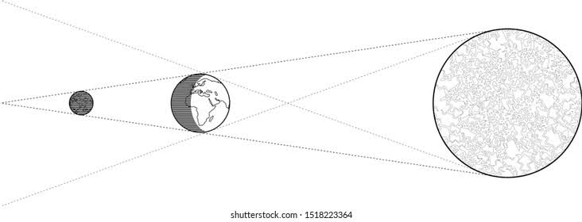

(i) What type of Eclipse is represented by the diagram? (1 mark)

* **Lunar**

(ii) Explain how the eclipse above occurs. (2 marks)

* **It occurs when the sun rays are blocked by the earth from reaching the moon.**
* **It occurs when the earth is between the sun and the moon.**

(b) What is the time at Malindi on 400E when the time at Accra on longitude 00 is 12:00 noon? (2 marks)

**Difference in degrees = 400**

**10 = 4 min**

**400 x 4 = 160 minutes**

**= 2 hr 40 min**

**12:00 + 2:40 mins = 14:40 hrs or 2:40 pm.**

3.(a) Apart from Fold Mountains, name three other features resulting from folding. (3 marks)

• **Rolling plains**

• **Ridge and valley landscape**

• **Inter-montane plateaus**

• **Inter-montane basins**

• **Synclinal valleys / depressions**

|  |  |  |  |
| --- | --- | --- | --- |
|  | (b) | State **two** factors that determine the folding of crustal rocks. | (2 marks) |
|  |  | • **Strength of intensity of the compressional force**  • **Temperature within rocks**  • **The age of sedimentary rocks** |  |
| 4. | (a) | Give **three** reasons why some Lakes of Kenya have saline water. | (3 marks) |

• **High temperature in the locality of the lakes which leads to high evaporation rates resulting in the accumulation of salts in the lakes**

• **Some lakes are fed by underground streams or underground water containing large amount of dissolved salts.**

• **Some lakes have salty bed rocks which get dissolved water in the lakes**

• **Some rivers and run-off water draining into the lakes bring in large amounts of dissolved salts.**

(b) Outline **two** economic uses of lakes. (2 marks)

• **Fresh water lakes provide fresh water for domestic and industrial use**

• **Fresh water lakes provide irrigation water thus promoting agriculture**

• **Man-made lakes are used to generate HEP for domestic and industrial uses**

• **Some lakes provide a cheap means of transport thus promoting trade**

• **Some lakes have valuable minerals that are exploited for income and as industrial raw-materials**

• **Some lakes are sources of fish which promotes the fishing industry**

• **Some lakes are sources of fish which promotes the fishing industry**

• **Many lakes attract tourists for recreation thus bringing in foreign exchange**

5. (a) What is natural vegetation? (2 marks)

**Natural vegetation is the plant cover growing in an area without interference by man or animals.**

(b) State three characteristics of the Mediterranean type of vegetation.(3 marks)

• **Waterlogged areas support swamp vegetation**

• **Most forests have thick forests**

• **Some plants are evergreen**

• **Most trees are of moderate height with few branches**

• **Dry areas have woody and scrub vegetation**

• **Some areas have shrubs, thickets and thorn bush**

**SECTION B**

Answer question 6 and any other two questions from this section.

6. Study the map of Mumias 1:50,000 (Sheet 101/2) provided and answer the following questions.

(a) (i) Identify two types of scales that have been used in the map extract.(2 marks)

* Representative fraction/ Ratio scale
* Linear scale

(ii) What was the magnetic declination of Mumias as at January 1965?

* 2° 19′

(iii) Name three Districts covered by the map of Mumias. (3 marks)

* Busia District
* Kakamega District
* Bungoma District
* Siaya District

(iv) Measure the length of the dry weather road from the junction at grid reference 6028 up to the bridge at grid reference 6434. Give your answer in KM. (2 marks)

* 6.8 km ±0.1 (6.7 – 6.9 km)

(b) Reduce by two, the area to the East of Easting 50 and enclosed by Northing 30 to 40. (2 marks)

On it mark and name:

* River Nzoia
* All weather road loose surface
* District boundary
* Seasonal swamp

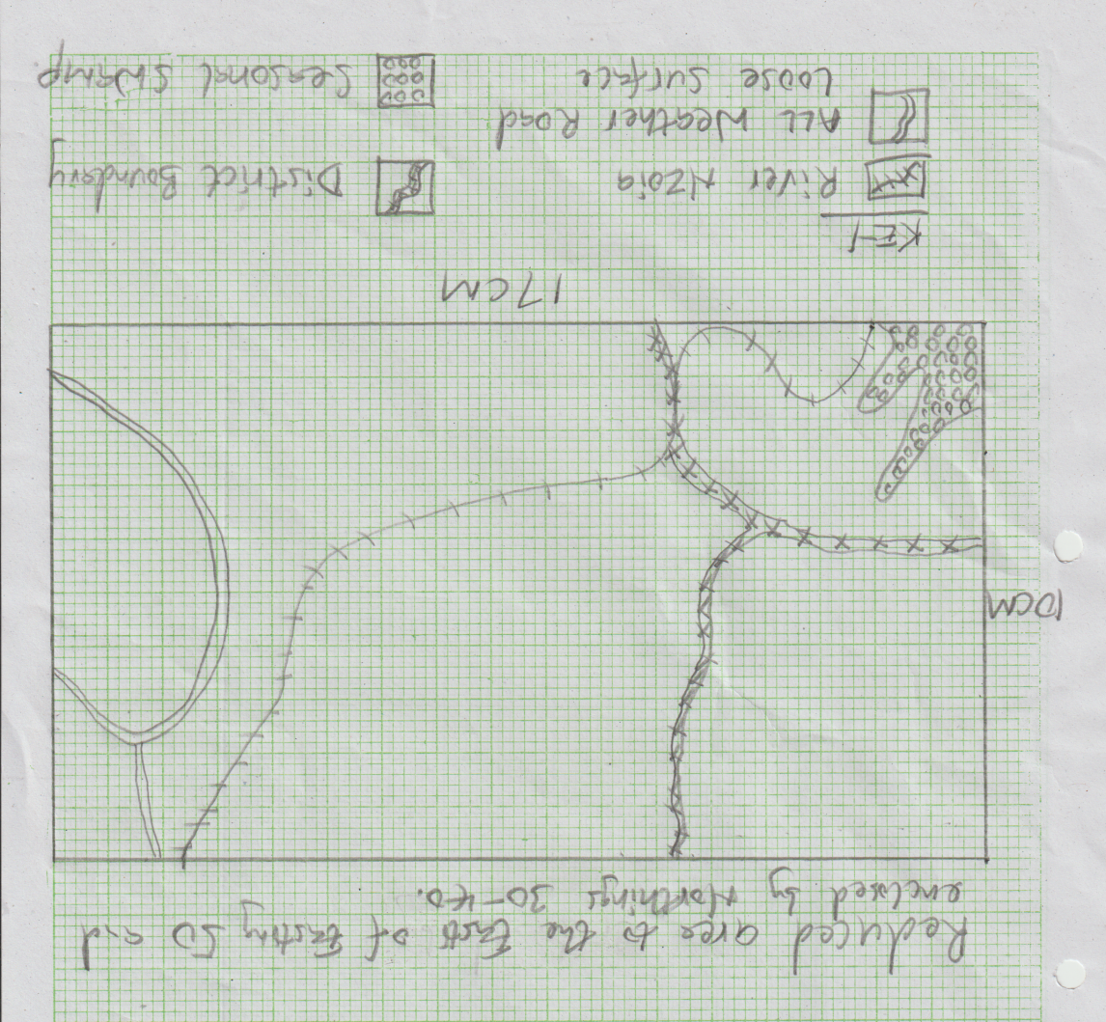

(ii) Calculate the new scale for the reduced area. (2 marks)

* **New scale: 1:50,000**×**2** = **1:100,000**

(c) Describe the drainage of the area covered by the map. (5 marks)

* There are many permanent rivers in the area
* The main river is River Nzoia
* River Nzoia flows towards the South Western side of the area covered by the map.
* There are several seasonal/papyrus swamps in the area covered by the map
* There are disappearing rivers in the area covered by the map
* Some rivers form dendritic drainage patterns with their tributaries.
* There are dams at Bumala, Buhuyi

(d) Citing evidence from the map, identify two economic activities carried out in the area covered by the map. (4 marks)

* **Trade as evidenced by markets**
* **Transport as evidenced by many roads**

**s**

**\*NB ACTIVITY can score on its own but not evidence**

7. (a) (i) What is a rock? (2 marks)

- **It is any naturally occurring agglomeration of mineral particles forming part of the earth’s crust.**

(ii) Describe the following characteristics of mineral:

• Tenacity (2 marks) **Tenacity is the ability of a mineral to withstand the tearing, crushing or breaking.**

• Lustre (2 marks)

**Lustre is the ability of a mineral to reflect light, the quality of being bright.**

• Cleavage (2 marks)

**Cleavage is the tendency of a mineral to break into some given parts.**

(b) (i) Name **two** examples of intrusive igneous rocks. (2 marks)

- **Granite**

- **Peridotite**

- **Diorite**

- **Syenite**

- **Gabbro**

(ii) Describe the formation of Plutonic rocks. (4 marks)

- **Earth movements form cracks in the earth’s crust.**

- **Due to intense heat and pressure, magma in the earth’s interior is forced to intrude the earth’s crust.**

- **The intruding magma may get trapped in the earth’s crust.**

- **The magma cools and solidify to form coarse grained rocks due to slow cooling.**

(c) Explain **three** significance of rocks to the economy of Kenya. (6 marks)

- **Some rocks weather to form deep soils which are used for agriculture thus generates income for many people.**

- **Some rocks weather to form unique features that create a beautiful sceneries that attract tourists thus generates income for the country when tourists visit to see them.**

- **Some rocks provide building and construction materials thus promoting the building industry.**

- **Soap stones are curved into artifacts which are sold to generate income.**

- **Rock salts are sources of food for people and animals which improves their diet.**

- **Some rocks are source of income, e.g gemstones for ornamental value which are** **sold for income.**

- **Some rocks are used to make fertilizers which are important for agriculture.**

- **Some rocks reserve underground water which is exploited for**

**domestic, agricultural and industrial use.**

- **Some sedimentary rocks reserve fossil fuels which are exploited to produce energy for domestic and industrial use.**

- **Some rocks have valuable mineral which are exploited and sold to**

**generate income for the country.**

(d) Your class is planning to carry out a fieldwork on rocks around your school.

(i) Outline **two** activities you would engage in before the study.

- **Seeking permission from the relevant authorities.**

- **Setting the objectives and hypotheses.**

- **Reading more about the topic of study.**

- **Holding discussions on the topic of study.**

- **Carrying out a pre-visit / reconnaissance.**

(2 marks)

- **Preparing questions and questionnaire to be used during fieldwork for data collection.**

- **Deciding on means of travelling to the area of study.**

- **Obtaining a route map.**

- **Gathering the relevant materials and tools for the fieldwork.**

- **Conduction sampling in case the area is too large.**

- **Dividing the class into groups and appointing the group leaders.**

- **Preparing working schedule.**

(ii) State **two** challenges you are likely to face during the field study.

(2 marks)

- **Language barrier causing miscommunication between the researcher and the respondents leading to inaccurate data.**

- **Occurrence of heavy rainfall which interrupts the data collection**

**process.**

- **Hostility from some of the respondents leading to unavailability of data.**

- **Dishonest respondents leading to obtaining of wrong information.**

- **Occurrence of accidents in the field thus inconveniencing the data collection process.**

- **Attack by some wild animals leading to inconveniencing of data**

**collection process.**

- **Inaccessibility of some areas due to steep slopes thus making data collection process impossible.**

- **Fatigue**

- **Sudden illness among the students.**

8. (a) (i) Outline **three types of river erosion. (3 marks)**

* **Headward erosion**
* **Vertical erosion**
* **Lateral erosion**

(ii) State three factors that influence river erosion. (3 marks)

- **River volume / stream volume / volume of water in the stream**

- **Gradient and velocity of the river**

- **Nature and the amount of load**

- **Nature of bed rock in the river channel**

(b) Describe how the river erodes through the following processes;

(i) Hydraulic action (4 marks)

- **This is the quarrying effect of moving water.**

- **As the river flows water is forced ion the river banks with cracks and joints.**

- **Air in the cracks is compressed.**

- **The compressed air creates pressure on the cracks so the cracks widens.**

- **As the water retreats, pressure on the cracks so the cracks widens.**

- **As the water retreats, pressure in the cracks is released suddenly.**

- **Repeated compression and widening of the cracks causes the rocks to break / shatter.**

- **The retreating water carries away loose rock particles.**

- **The force of moving water and eddying currents sweep away the loose materials in the channels.**

(ii) Solution (2 marks)

**- This is the corrosive effect of river water on the rocks over which the river flows.**

**- Soluble minerals in the river channel are dissolved by river**

**water or presence of organic acids.**

**- The dissolved load is then carried downstream in solution form.**

(c) Describe how the following features are formed:

• Interlocking spurs (4 marks)

**- Highlight projections into the river valley which appear as they fit each other.**

**Formation**

**- A river flows swiftly in its youthful stage.**

**- When it meets a resistant rock, the river flows swiftly around it instead of cutting through, so it forms a winding course.**

**- The river erodes the outer banks of the winding channel than the**

**inner banks because of strong water currents.**

**- This causes the bends to be more pronounced hence the formation of interlocking spurs.**

**- The outer bank are undercut becomes river cliff / bluff while**

**materials are deposited the inner bank forming gentle sloping banks called slip off slope.**

• Natural levees (4 marks)

- **Raised river banks / embankments which are made of alluvial materials.**

**Formation**

**- During heavy rains, river floods and spills over its banks.**

**- Due to this, the speed of the water suddenly reduces.**

**- Coarser materials are deposited immediately near the river banks and fine materials are carried further on to the flood plain.**

**- Coarse materials also accumulate on the river bed.**

**- After the flood, the volume of water subsides and the river returns to the river channel, so deposited occur on the river bed.**

**- With time repeated deposition causes the river bed and the river banks to be raised.**

**- The raised river banks are then referred to as natural levees.**

(d) Explain three negative effects of rivers. (6 marks)

- **Rivers flood causing loss of life, displacement of people and destruction of property.**

- **River water can be a medium of spreading waterborne diseases such as**

**bilharzia and malaria.**

- **Some rivers are wide and deep acting as barriers to transport and communication and also make it difficult and expensive.**

- **Some rivers harbor dangerous wild animals which can kill human being**

**e.g. crocodiles, hippos and snakes.**

9. (a) (i) Differentiate between Vulcanicity and volcanicity. (2 marks)

• **Vulcanicity is the process through which liquid gaseous and solid materials are forced out of the earth’s interior into the rocks of the crust or ejected to the surface. While volcanicity is the process where molten rock from the earth’s interior called magma reaches thes earth’s surface to form extrusive volcanic features.**

(ii) Describe how lava plateau is formed. (4 marks)

**Earth movements form many fissures or vents in the rocks or he crust. Ultra-basic magma reaches the ground surface through the fissures or vents in a quiet eruption.**

**The highly fluid hot lava flows and spreads out on the earth’s surface to cover long distance and wide areas.**

**The lava fills and cover valleys and depressions on the earth’s surface. The lava cools and solidifies to cover an extensive fairly flat lowland**

**area called a lava plain.**

**Successive eruptions leads to accumulation of thick layers of lava forming a solid layers of lava of extensive and fairly flat upland are called a lava plateau.**

(b) The diagram below shows some intrusive features formed by vulcanicity.

Use it to answer questions that follow.

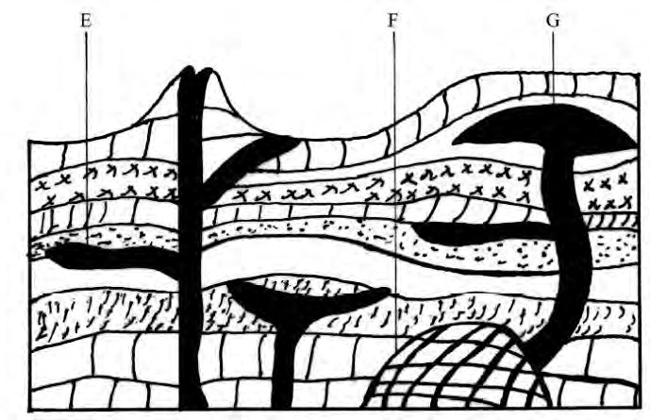

|  |  |  |
| --- | --- | --- |
| I. | Name the features marked E, F and G. | (3 marks) |
|  | **E – Dyke**  **F – Batholith**  **G – Laccolith** |  |
| II. | Explain how feature marked E is formed. | (4 marks) |

**Earth movements form a vertical or an inclined vent across the crustal rock layers. Magma is forced upwards through the vents magma cools and solidifies slowly inside the vent forming a wall- like mass of intrusive igneous rocks called a dyke.**

(c) Students carried out a field study on volcanic rocks.

(i) Give **four** reasons why it is necessary to collect rock samples during such a field study. (4 marks)

• **There is no field laboratory where the rock samples can be analyzed**

• **There is no adequate time in the field**

• **To enable them build a collection of rock samples**

• **It would expose more students to their findings through display of their findings**

• **To create interest**

(ii) Outline **four** follow-up activities the learners would be engaged in after the field study. (4 marks)

• **Discussing the findings in class in groups**

• **Writing reports in essay form**

• **Calculation of percentages, means, medians**

• **Laboratory testing of samples**

• **Presentation of data using methods such as graphs**

(d) (i) Give **four** causes of Earthquakes. (4 marks)

|  |  |  |  |
| --- | --- | --- | --- |
|  |  | • **Movement of tectonic plates**  • **Gravitative pressure**  • **Movement of magma within the rocks**  • **Folding and faulting of rocks of the crust**  • **Isostatic adjustment**  • **Energy release from the mantle** |  |
|  |  |  |
|  |  |  |  |
| 10. (a)(a) | 1. (i) | What is soil catena? | (2 marks) |

- **Soil catena is the sequence of different soils from the same parent**

**rock on a slope.**

(ii) Give three factors that determine the colour of soil. (3 marks)

- **The type of parent rock**

- **The amount of organic matter / humus**

- **The chemical composition / minerals**

- **The amount of water in the soil**

(iii) State three ways in which mulching helps in soil conservation.

(3 marks)

- **Plant materials used decompose increasing soil humus**

- **It protects the soil against wind erosion**

- **It protects the helps to increase infiltration rate of water in the soil.**

- **It helps reduce water loss from the soil / retain soil moisture.**

(b) Explain how the following farming practices causes soil erosion.

(i) Burning (4 marks)

- **Burning destroys micro-organisms which are essential for the formation of humus which binds soil particles together**

- **Burning destroys vegetable matter that protects the soil against erosion**

- **Burning destroys the nitrogen fixing bacteria making the soil less fertile and therefore few plants and less protection of the soil.**

- **Burning loosens the soil making it susceptible to erosion.**

(ii) Over cultivation (4 marks)

- **Over cultivation leads to exhaustion of certain minerals from the soil making it infertile and bore leading to its erosion.**

- **Over cultivation leads to loosening of soils particles there by**

**encouraging soil erosion.**

(c) Give two economic uses of soil. (2 marks)

- **It is used as raw material in pottery / glass making /brick making**

- **Soils supports agriculture**

- **Some soils contain valuable minerals**

- **Some soils have medicinal value / food**

- **It is used in building and construction**

(d) You are supposed to carry out a field study of an eroded area:

(i) State three methods you would use to control soil erosion. (3 marks)

- **Construction of gabions**

- **Afforestation / reafforestation**

- **Construction of drainage trenches**

- **Construction of check dams**

- **Filling in the gullies**

(ii) What would be disadvantages of using secondary methods of collecting data in this kind of study? (2 marks)

- **Recorded data could be out of date**

- **Conditions under which such data was collected may be changed**

- **Obtaining records on the particular soil area may be difficult.**

(iii) Identify two methods you would use to record the observations.

(2 marks)

- **Photographing**

- **Note taking**

- **Video recording**

- **Field sketching**